EDGE Physical Therapy & Sports Medicine

Patient Name: _________________________________________ Date: _______________
Why are you here today? Chief Complaint: ___________________________________________________________

Have you ever suffered or have been told that you have: |  |  | Have you recently experienced:
High blood pressure | YES | NO | Weight loss/gain | YES | NO
Heart problems | YES | NO | Pain at night | YES | NO
Lung Problems | YES | NO | Fatigue/malaise | YES | NO
Head injury | YES | NO | Difficulty sleeping | YES | NO
Multiple sclerosis/Parkinson’s Disease | YES | NO | Joint pain and/or swelling | YES | NO
Stroke | YES | NO | Urinary or bowel problem | YES | NO
Liver problems | YES | NO | Nausea and vomiting | YES | NO
Thyroid problems | YES | NO | Numbness or tingling, if yes where? | YES | NO
Blood disorders | YES | NO | Weakness in your arms or legs | YES | NO
Diabetes (high blood sugar) | YES | NO | Coordination problems | YES | NO
Low blood sugar | YES | NO | Difficulty walking | YES | NO
Cancer | YES | NO | Dizziness or loss of consciousness | YES | NO
Arthritis | YES | NO | Chest pain | YES | NO
Osteoporosis | YES | NO | Heart palpitations | YES | NO
Circulatory or vascular problems | YES | NO | Short of breath | YES | NO
Broken bones (fractures) | YES | NO | Difficulty swallowing | YES | NO
Other orthopedic problems | YES | NO | New onset of headaches | YES | NO
Chronic pain | YES | NO | Visual problems | YES | NO
Ulcers/stomach problems | YES | NO | Hearing problems | YES | NO
Chronic migraines | YES | NO |  | YES | NO
For men only: |  |  | Do you:
Prostate disease | YES | NO | Smoke | YES | NO
For women only: |  |  | If yes, how much? ______ ppd ______ wkly | YES | NO
Pelvic inflammatory disease | YES | NO | Drink alcohol | YES | NO
Endometriosis | YES | NO | If yes, how much? _____per day ______ wkly | YES | NO
Complicated pregnancies | YES | NO | Any significant family historyof illness or disease | YES | NO
Trouble with your period | YES | NO | Other | YES | NO
Are you pregnant? | YES | NO |  | YES | NO

Please explain any YES answers here:________________________________________________________________
_________________________________________________________________________________________________ _________________________________________________________________________________________________
MEDICATION LIST: Dosage: MEDICATION LIST: Dosage:
_____________________________ ____________ ______________________________ ____________
_____________________________ ____________ ______________________________ ____________
_____________________________ ____________ ______________________________ ____________ _____________________________ ____________ ______________________________ ____________

EDGE Physical Therapy & Sports Medicine

Have you had surgery or been hospitalized in the past? YES or NO

Date/reason: _____________________________________________________________________________________

_________________________________________________________________________________________________

Any scars? (other than surgeries listed above) _________________________________________________________
Who is the primary physician that you see most often? __________________________________________________

Pain Level: 0 = No Pain 10 = Extreme pain
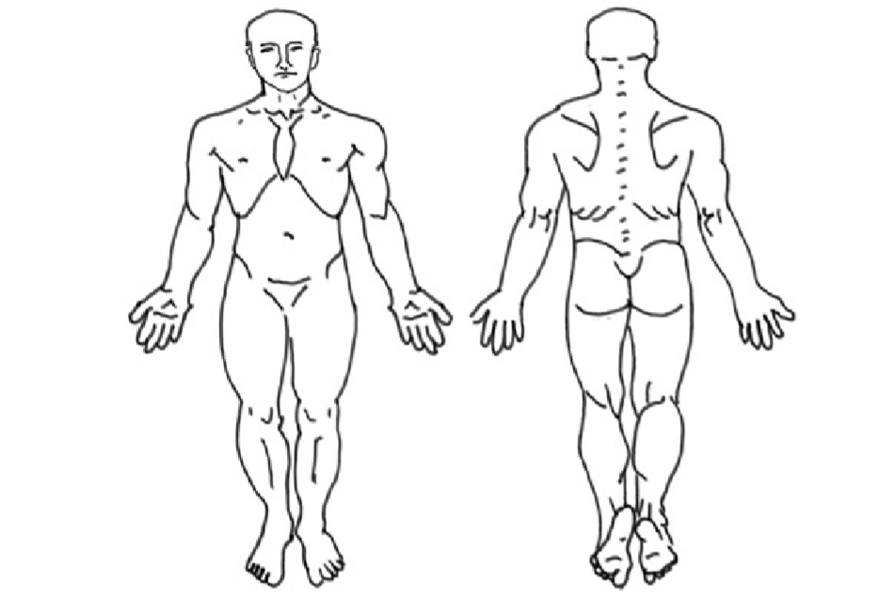
26. Please rate your current pain

0 1 2 3 4 5 6 7 8 9 10
27. Please rate your worst pain in the last week
0 1 2 3 4 5 6 7 8 9 10
28. Please rate your least pain in the last week
0 1 2 3 4 5 6 7 8 9 10

Please shade the areas where you are having pain.

Patient/Guardian Signature _________________________________________ Date: _______________

